
One-to-One Technology
Chromebook Information Handbook
September 2015

WHY?
At Lundavra Primary our vision is to transform the way Digital Learning is used to support Learning and Teaching.
At the heart of our vision are our learners, who have a basic entitlement to access appropriate technologies for their learning.
CHROMEBOOK FAQS
What is a Chromebook?
“Chromebooks are mobile devices designed speciﬁcally for people who live on the web. With a comfortable, full-sized keyboard, large display and clickable trackpad, all-day battery life, lightweight and built-in ability to connect to Wi-Fi, the Chromebook is ideal for anytime, anywhere access to the web. They provide a faster, safer, more secure online experience for people who live on the web, without all the time-consuming, often confusing, high level of maintenance required by typical computers.” Google
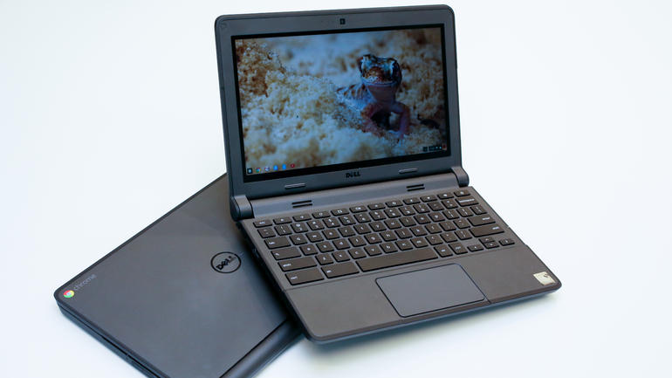
What kind of software does a Chromebook run?
“Chromebooks run millions of web-based applications, or web apps, that open right in the browser. You can access web apps by typing their URL into the address bar or by installing them instantly from the Chrome Web Store.” Google

How are these web-based applications managed?
Each Chromebook we provide to students will be a managed device. We will maintain devices through our Google Apps for Education account. As such, the school can pre-install web-applications as well as block speciﬁc web-applications from a management console.
What devices can I connect to a Chromebook?
Chromebooks can connect to:
- USB storage, mice and keyboards.
- SD cards
- External monitors and projectors
- Headsets, earsets, microphones
Can the Chromebook be used anywhere at anytime?
Yes, as long as you have a Wi-Fi signal to access the web. Chrome also offers the ability through Apps so users can work in an "ofﬂine" mode if required.
Do Chromebooks come with Internet Filtering Software?
No. Chromebooks do not come with internet ﬁltering software. However, while in school Chromebooks will use the School’s W-iFi to access the internet which is ﬁltered. While at home, the Chromebooks will be ﬁltered based on the protection provided by your home Wi-Fi system.

Is there antivirus built into it?
It is not necessary to have antivirus software on Chromebooks because there are no running programs for viruses to infect.
General Precautions
No food or drink is allowed next to your Chromebook while it is in use.
Cords, cables, and removable storage devices must be inserted carefully into the Chromebook.
Never transport your Chromebook with the power cord plugged in. Never store your Chromebook in your carry case or backpack while plugged in.
Students should never carry their Chromebooks while the screen is open.
Chromebooks must remain free of any writing, drawing, or stickers.
Vents CANNOT be covered.
Chromebooks should never be left in an unsupervised area.
Chromebook lids should always be closed and tightly secured when moving.
Never move a Chromebook by lifting from the screen. Always support a Chromebook from its bottom with lid closed.
The Chromebook screens can be easily damaged. The screens are particularly sensitive to damage from excessive pressure on the screen.
Using Your Chromebook at School
Chromebooks are intended for use at school each day.
In addition to teacher expectations for Chromebook use, school messages, announcements, calendars and schedules may be accessed using the Chromebook.

Password
Pupils will be supported to set an individual password
Take care to protect your password.
DO NOT SHARE YOUR PASSWORD!

Managing and Saving Your Work
Google Apps for Education is a suite of products which includes mail, calendar, sites, word processing, presentations, drawings, spreadsheets, forms, etc. that lets you create different kinds of online documents, collaborate in real time with other people, and store your documents, as well as your other ﬁles, in the cloud.
With a wireless Internet connection, you can access your documents and ﬁles from any Chromebook, anywhere, at any time, no matter where you are. All items will be stored online in the Google Cloud environment.

Operating System on Your Chromebook
Updating Your Chromebook
When a Chromebook starts up, it updates itself automatically, so it has the most recent version of the Chrome operating system without you having to do a thing. No need for time-consuming installs, updates, or re-imaging.

Virus Protection and Additional Software
With defence-in-depth technology, the Chromebook is built with layers of protection against malware and security attacks.
Files are stored in the cloud, so there’s no need to worry about lost homework.

Acceptable Use Guidelines

Be Secure
This is important as the Highland Council provides every person with their own username and password to log on to the system. Each pupil has their own settings and filters on internet access so they only access information suited to their age group. Pupils can also access their work from any device in the school. Sharing usernames and passwords to enable another person to log on is unsafe use of the ICT equipment and is not permitted.
This point is also vital to remember for any account. ‘Treat your passwords like your toothbrush’ – as in never share and change them often! This is a fun way to get children and young people to think about their passwords. Sometimes people have one password or phrase for all their accounts such as, Hotmail, Facebook or Twitter. If a password or passphrase is shared someone might get access to many more sites and lots of personal information.
Sometimes children and young people like to show they trust their friends by letting them have their password. Try to ensure that pupils understand that they are protecting their friends by not giving them their passwords. It is advisable to have complex passwords or phrases which can prevent people guessing them or prevent specifically designed computer programs hacking accounts to gain access.
In using a computer or device it is important to ‘log off’ or ‘screen lock’. Quite often pupils (and adults) multi-task and will walk away from the screen momentarily. Being mindful of logging off or locking the screen helps to protect ourselves and the equipment. If the device or machine is left open and the pupil is logged on, it may be possible for another user to access their files, pretend to be them and potentially cause mischief which would appear to be the person logged in!
Be Respectful
Lundavra Primary School promotes positive behaviour in school and the same behaviour is expected online. This point also helps pupils to understand that that communication online is the same as in the offline world both in and out of school. Bullying by use of electronic means has been referred to as ‘Cyberbullying’. Any form of abuse or bullying behaviour in school is not tolerated and will be dealt with as per the school’s anti-bullying approach.

Be Safe
Personal information online might attract unwanted email from hackers, unpleasant phone calls or messages, or being bombarded with advertising emails. If someone had all these bits of information collectively such information could provide enough detail to steal a pupil’s identity. It could be possible to open a fake account and take out a credit card or loan. It is important that pupils understand the need to protect their information and that they also have a responsibility to protect information belonging to others too.
This is a key principle that is taught across all safety education. Some pupils find it easy to build up trust with someone they haven’t met before, either through gaming, social networking or chat room
Not all people are who they say they are online. It is important to explain that ‘no matter how much you think you know someone and develop a friendship with them, you must never meet up with anyone without your parent, carer or trusted adult’.
Although the internet in school has a filter in place, sometimes pupils may see something that worries them or they are not emotionally ready for. This may be content on a website, text or images in a document or a message or posting online. Seeing something like this this is not exclusive to unpleasant sites but often adverts or news items are not suitable for children or young people. It is important to encourage pupils to tell someone if they see content like this so that the teacher or adult can take action. This may be reporting a website to an agency like the Internet Watch Foundation, adjusting filtering settings or simply being supportive with advice and explanations.

Be Responsible
In schools, the internet is filtered in a way that allows access to sites relevant for pupils to enable them to be creative, carry out research for their learning and look at sites relevant to education. The filter prevents access to sites which contain content that is not appropriate without being prohibitive to learning. However, some pupils can access the unfiltered internet on their personal devices like phones, mobile tablets and gaming devices, digital television receivers and computers at home or via the phone signal. For these reasons pupils are encouraged to think about how to search for information, critically think about content online and also be responsible about the places visited on the internet.

Be Legal
In any use of the internet, it’s important to encourage pupils to think about the content of photos or film that they might upload themselves. Is this something they wish to share online? Content is out with anyone’s control once posted; other people may share it too. It’s also important to think about the future. A digital “footprint” is being created which can paint a picture of a person which can be found in the future.

